**OPERATING SYSTEMS**

**LABSHEET 3**

**Anuvind MP**

**AM.EN.U4AIE22010**

1. Write shell scripts for the following:

a. To take your name, programme name and enrolment number as input from user

and print it on the screen.

#!/bin/sh

echo "Q1-a"

read -p "Enter your name : " name

read -p "Enter programme name : " programme

read -p "Enter enrolment number : " enrolement

echo -e "Name : " $name

echo "Programme : " $programme

echo "Enrolement number : " $enrolement

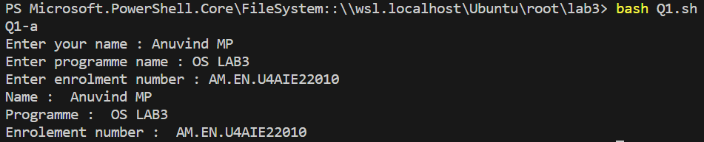

b. To find the sum, the average and the product of four integers.

#!/bin/sh

read -p "Enter a number : " a

read -p "Enter a number : " b

read -p "Enter a number : " c

read -p "Enter a number : " d

sum=$((a + b + c + d))

avg=$((sum / 4))

product=$((a * b * c * d))

echo "sum = $sum"

echo "Average = $avg"

echo "Product = $product"

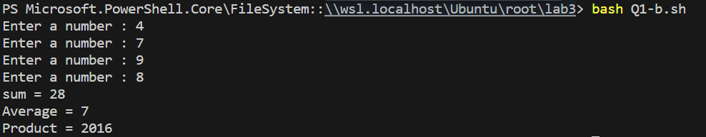

c. Write a program to check whether a number is even or odd.

#!/bin/sh

read -p "Enter a number : " a

if (($a % 2 == 0))

then

    echo "$a is even"

else

    echo "$a is odd"

fi

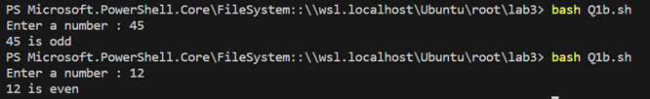

d. To exchange the values of two variables.

#!/bin/sh

read -p "Enter a number : " a

read -p "Enter a number : " b

temp=$a

a=$b

b=$temp

echo "After exchanging :"

echo "Variable 1 : $a"

echo "Variable 2 : $b"

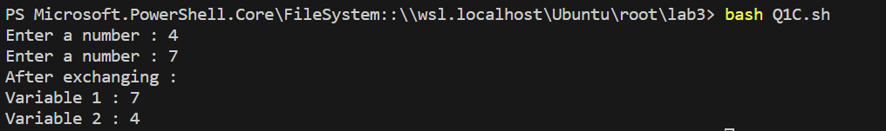

e. To find the lines containing a number in a file.

#!/bin/sh

read -p "Enter file name : " file

read -p "Enter number to search : " num

grep "$num" "$file"

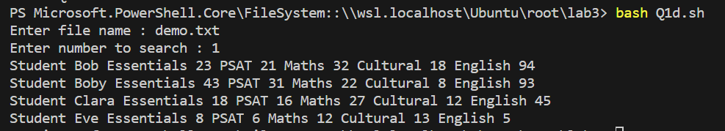

f. To concatenate two strings and find the length of the resultant string.

#!/bin/sh

read -p "Enter string 1 : " str1

read -p "Enter string 2 : " str2

con="$str1$str2"

len=${#con}

echo "Concatenated string : $con"

echo "Length of the string : $len"

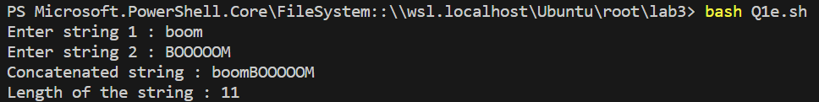

g. To concatenate the contents of two files.

#!/bin/sh

read -p "Enter file 1 : " f1

read -p "Enter file 2 : " f2

cat "$f1" "$f2"

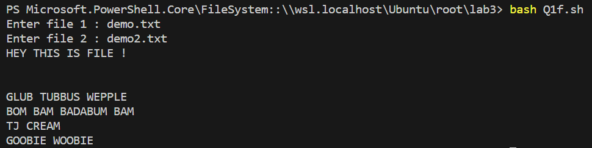

h. Write a shell script that would wait 5 seconds and then display the time

#!/bin/sh

sleep 5

echo "Time : $(date)"



2. The length and breadth of a rectangle and radius of a circle are provided as user input.

Write a shell script that will calculate the area and perimeter of the rectangle and the

area and circumference of the circle.

Hint:- Area of Rectangle = L*B Perimeter of Rectangle = 2(L+B) Area of Circle = π.r2

Circumference of circle = 2. π.r

#!/bin/sh

read -p "Enter length of rectangle: " l

read -p "Enter breadth of rectangle: " b

perimeter=$((2 * (l + b)))

area=$((l * b))

echo "Rectangle Perimeter: $perimeter"

echo "Rectangle Area: $area"

read -p "Enter radius of circle: " r

circle_area=$(echo "scale=3; 3.141 * $r * $r" | bc)

circle_circum=$(echo "scale=3; 2 * 3.141 * $r" | bc)

echo "Circle Area: $circle_area"

echo "Circle Circumference: $circle_circum"

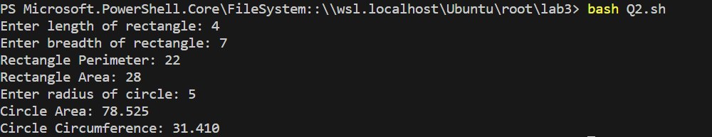

3. Write a menu driven shell program to read two numbers and print the results of all the

arithmetic operations. ( + , - , * , / , % , ++ , -- )

#!/bin/bash

echo "Menu:"

echo "1. Addition"

echo "2. Subtraction"

echo "3. Multiplication"

echo "4. Division"

echo "5. Modulus"

echo "6. Increment"

echo "7. Decrement"

read -p "Enter the First Number: " num1

read -p "Enter the Second Number: " num2

read -p "Enter the Operation (1-7): " op

case $op in

    1)  res=$((num1 + num2)); echo "Sum: $res";;

    2)  res=$((num1 - num2)); echo "Difference: $res";;

    3)  res=$((num1 * num2)); echo "Product: $res";;

    4)  if (( $(echo "$num2 != 0" | bc -l) )); then

            res=$(echo "scale=2; $num1 / $num2" | bc)

            echo "Quotient: $res"

        else

            echo "Cannot divide by zero."

        fi;;

    5)  if (( $(echo "$num2 != 0" | bc -l) )); then

            res=$((num1 % num2))

            echo "Remainder: $res"

        else

            echo "Cannot find remainder when dividing by zero."

        fi;;

    6)  res=$((num1 + 1)); echo "Increment of $num1: $res";;

    7)  res=$((num1 - 1)); echo "Decrement of $num1: $res";;

    *)  echo "Invalid operation.";;

esac

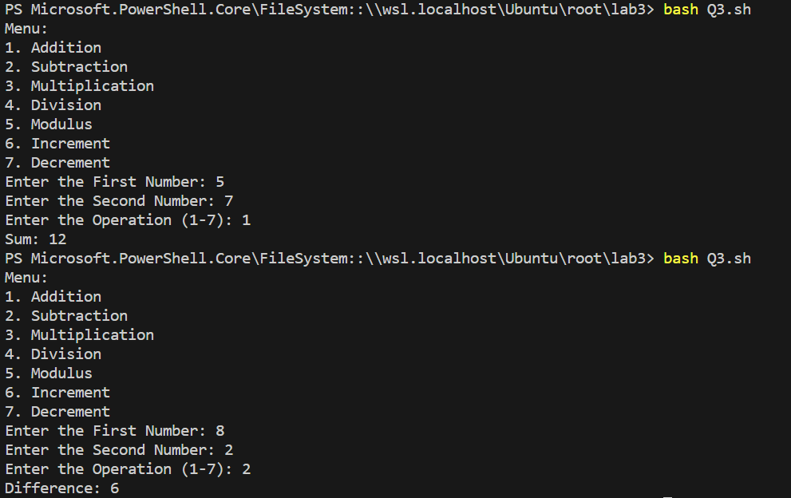

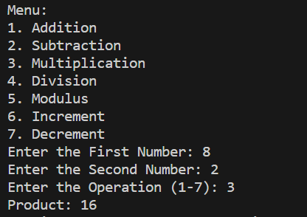 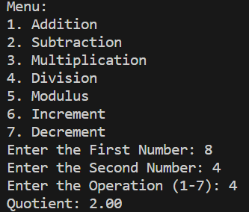

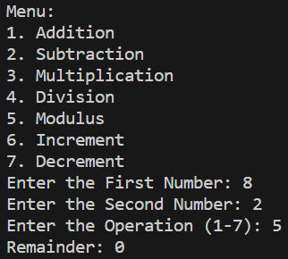 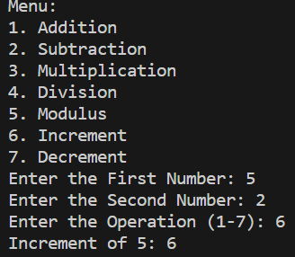

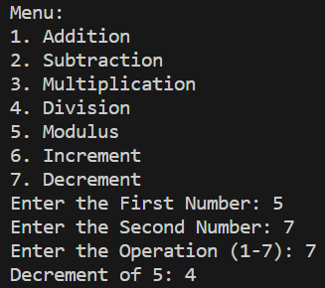

4. Write two separate shell scripts to find the factorial of a number using while statement

and for statement.

#!/bin/bash

read -p "Enter a Number to find its Factorial: " n

fact=1

for ((i = 1; i <= n; i++)); do

    fact=$((fact * i))

done

echo "Factorial of $n is: $fact"



5. Given a file of numbers (one number per line), write a shell script that will find the

lowest and highest number.

#!/bin/bash

file="demo2.txt"

if [ -f "$file" ]; then

    low=$(sort -n "$file" | head -n 1)

    high=$(sort -n "$file" | tail -n 1)

    echo "Lowest number: $low"

    echo "Highest number: $high"

else

    echo "File not found."

fi



6. Write a shell program to read n numbers into an array and display the average of them.

#!/bin/bash

read -p "Enter length : " n

declare -a array

for ((i = 0; i < n; i++)); do

    read -p "Enter Element $((i + 1)): " array[i]

done

sum_=0

for ((i = 0; i < n; i++)); do

    sum_=$((sum_ + array[i]))

done

average=$(echo "scale=2; $sum_ / $n" | bc)

echo "Average: $average"

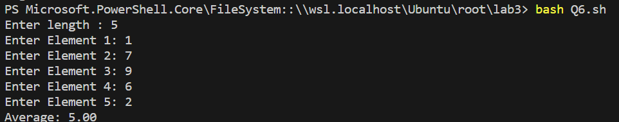

7. Write a shell program to print the following Patterns.

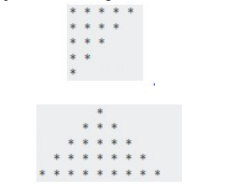

#!/bin/bash

echo "pattern 1 "

for ((i = 5; i >= 1; i--)); do

    for ((j = 1; j <= i; j++)); do

        echo -n "*"

    done

    echo

done

echo -e "\n"

echo "pattern 2 "

for ((i = 1; i <= 5; i++)); do

    for ((j = 5; j > i; j--)); do

        echo -n " "

    done

    for ((k = 1; k <= 2*i-1; k++)); do

        echo -n "*"

    done

    echo

done

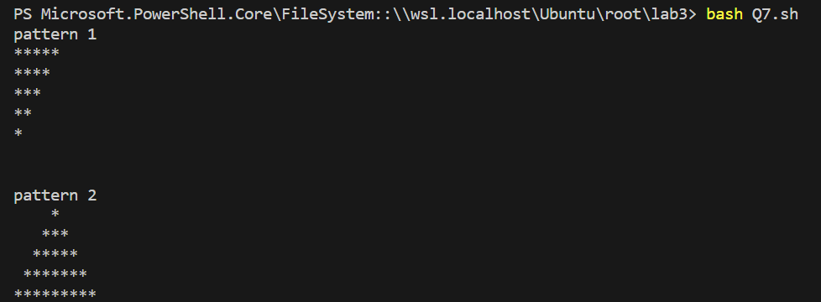

8. Write a shell program to read two matrices, add them and print the output matrix.

#!/bin/bash

read -p "Enter the Number of Rows : " m

read -p "Enter the Number of Columns : " n

declare -A matrix1

declare -A matrix2

echo "Enter elements for matrix 1:"

for ((i = 0; i < m; i++)); do

    for ((j = 0; j < n; j++)); do

        read -p "Enter element at position ($((i)), $((j))) for the first matrix: " matrix1["$i,$j"]

    done

done

echo "Enter elements for matrix 2:"

for ((i = 0; i < m; i++)); do

    for ((j = 0; j < n; j++)); do

        read -p "Enter element at position ($((i)), $((j))) for the second matrix: " matrix2["$i,$j"]

    done

done

echo "Matrix sum:"

for ((i = 0; i < m; i++)); do

    for ((j = 0; j < n; j++)); do

        result=$((matrix1["$i,$j"] + matrix2["$i,$j"]))

        echo -n "$result "

    done

    echo

done

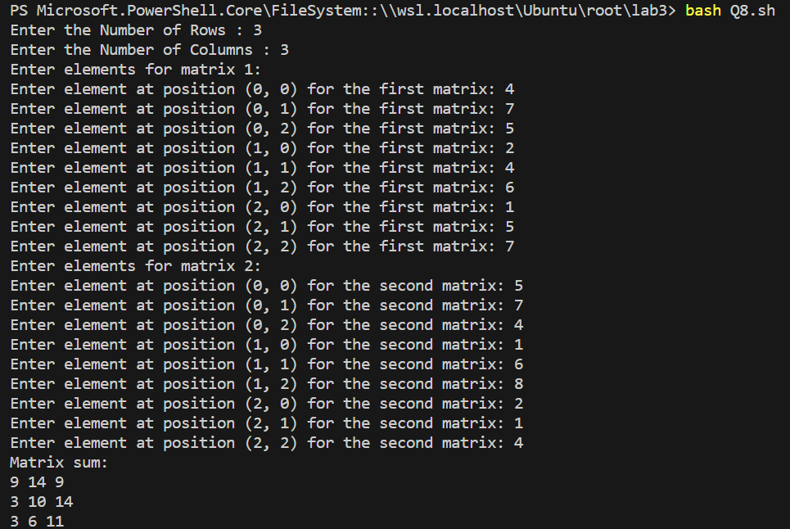

9. Write a program to read a matrix and print the transpose of it.

#!/bin/bash

read -p "Enter the Number of Rows : " m

read -p "Enter the Number of Columns : " n

declare -A A

echo "Enter Elements :"

for ((i = 0; i < m; i++)); do

    for ((j = 0; j < n; j++)); do

        read -p "Enter Element at position ($((i)), $((j))): " A["$i,$j"]

    done

done

echo "Transpose of the Matrix ' :"

for ((j = 0; j < n; j++)); do

    for ((i = 0; i < m; i++)); do

        echo -n "${A["$i,$j"]} "

    done

    echo

done

